Isosceles Triangle
# Source: AI Source: Provided by: [Data Path: Persons Table -> ID Column: 1, Name_En Column: Motasem Essam] -> From: [ChatGPT] on [7/25/2026]
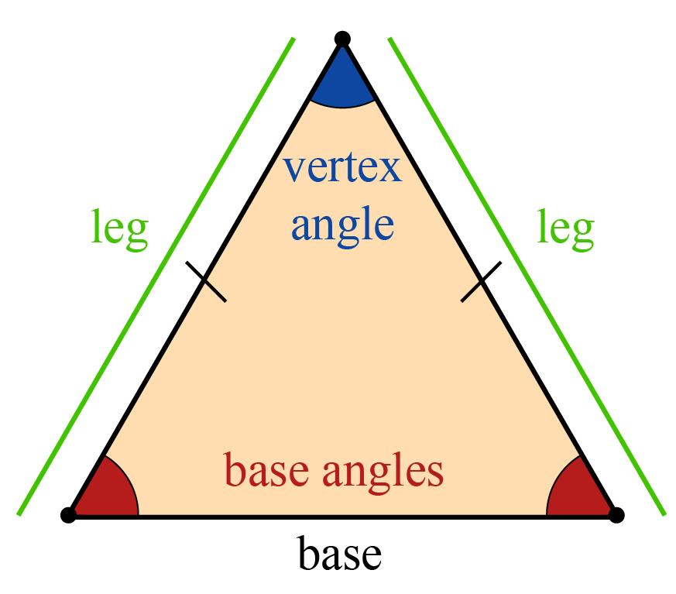
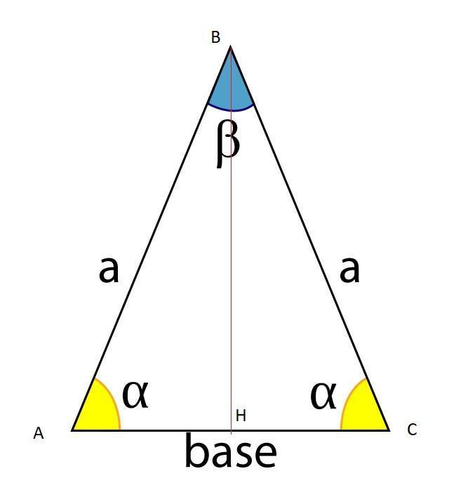
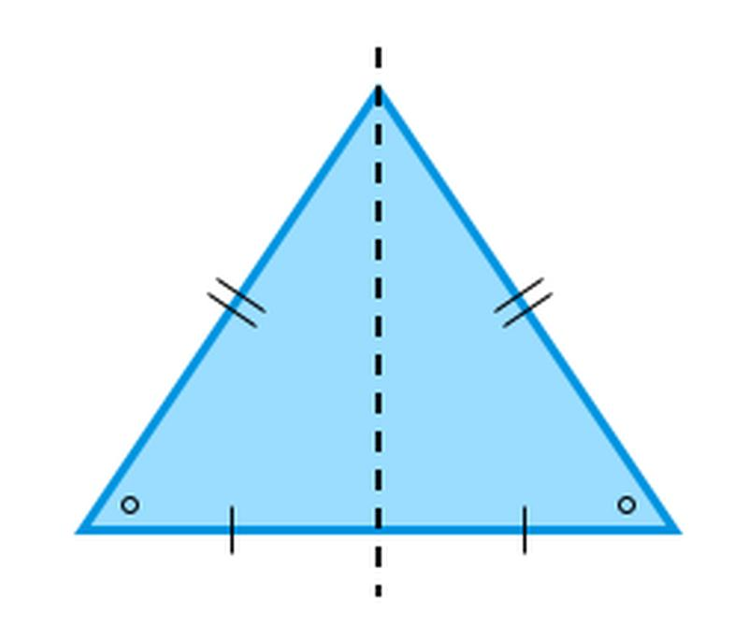
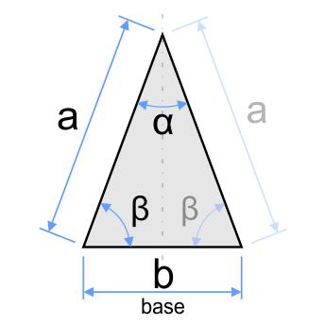
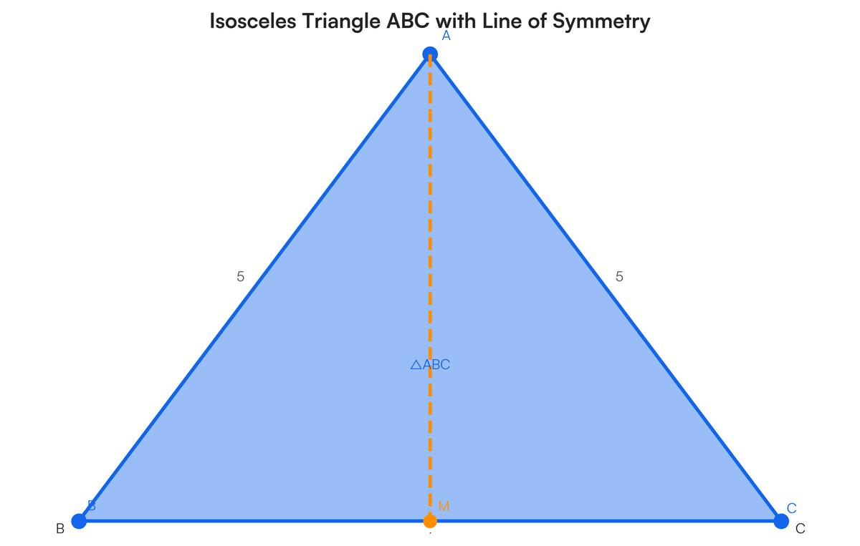

Definition
# Source: AI Source: Provided by: [Data Path: Persons Table -> ID Column: 1, Name_En Column: Motasem Essam] -> From: [ChatGPT] on [7/25/2026]
An isosceles triangle is a triangle that has at least two equal sides.
For triangle $ABC$, if:
$$\boxed{AB=AC}$$
then $ABC$is an isosceles triangle.
The two equal sides are called the legs, and the remaining side is called the base.
The angles opposite the equal sides are also equal:
$$\boxed{∠B=∠C}$$
These are called the base angles.
Classification note: Under the modern broad definition, an equilateral triangle is also an isosceles triangle because it has at least two equal sides. Some elementary classifications use “isosceles” to mean exactly two equal sides, in which case equilateral triangles are treated separately.
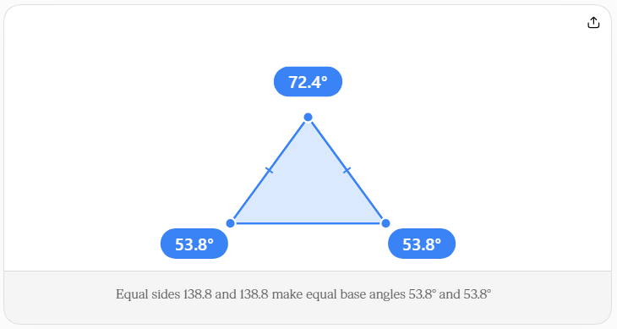

Classification
# Source: AI Source: Provided by: [Data Path: Persons Table -> ID Column: 1, Name_En Column: Motasem Essam] -> From: [ChatGPT] on [7/25/2026]
Triangles can be classified by their side lengths as:
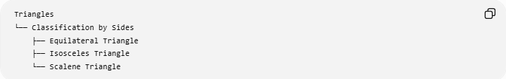
Triangles
└── Classification by Sides
├── Equilateral Triangle
├── Isosceles Triangle
└── Scalene Triangle
The defining condition for an isosceles triangle is:
$$\boxed{\text{At least two sides are equal}}$$

Fundamental Elements
# Source: AI Source: Provided by: [Data Path: Persons Table -> ID Column: 1, Name_En Column: Motasem Essam] -> From: [ChatGPT] on [7/25/2026]
For an isosceles triangle $ABC$with:
$$AB=AC$$
the elements are:
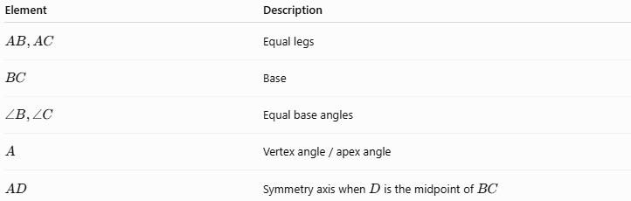
Element | Description
$$AB,AC$$ | Equal legs
$$BC$$ | Base
$$∠B,∠C$$ | Equal base angles
$$A$$ | Vertex angle / apex angle
$$AD$$ | Symmetry axis when $D$is the midpoint of $BC$

Main Properties

1. Two Equal Sides
# Source: AI Source: Provided by: [Data Path: Persons Table -> ID Column: 1, Name_En Column: Motasem Essam] -> From: [ChatGPT] on [7/25/2026]
The defining property is:
$$\boxed{AB=AC}$$

2. Equal Base Angles
# Source: AI Source: Provided by: [Data Path: Persons Table -> ID Column: 1, Name_En Column: Motasem Essam] -> From: [ChatGPT] on [7/25/2026]
The angles opposite the equal sides are equal:
$$\boxed{∠B=∠C}$$
This is known as the Isosceles Triangle Theorem.

3. Converse of the Isosceles Triangle Theorem
# Source: AI Source: Provided by: [Data Path: Persons Table -> ID Column: 1, Name_En Column: Motasem Essam] -> From: [ChatGPT] on [7/25/2026]
If two angles of a triangle are equal, then the sides opposite those angles are equal.
For example:
$$\boxed{∠B=∠C⇒AB=AC}$$
Thus, an isosceles triangle can be identified either from:
- two equal sides, or
- two equal angles.

Vertex Angle and Base Angles
# Source: AI Source: Provided by: [Data Path: Persons Table -> ID Column: 1, Name_En Column: Motasem Essam] -> From: [ChatGPT] on [7/25/2026]
If the vertex angle is $A$, then:
$$∠A+∠B+∠C={180}^{∘}$$
Since:
$$∠B=∠C$$
we can write:
$$\boxed{∠A+2∠B={180}^{∘}}$$
Therefore:
$$\boxed{∠B=∠C=\frac{{180}^{∘}-∠A}{2}}$$

Example
# Source: AI Source: Provided by: [Data Path: Persons Table -> ID Column: 1, Name_En Column: Motasem Essam] -> From: [ChatGPT] on [7/25/2026]
Suppose:
$$∠A={40}^{∘}$$
Because the triangle is isosceles:
$$∠B=∠C$$
Therefore:
$$∠B=∠C=\frac{{180}^{∘}-{40}^{∘}}{2} \\ \boxed{∠B=∠C={70}^{∘}}$$

Symmetry
# Source: AI Source: Provided by: [Data Path: Persons Table -> ID Column: 1, Name_En Column: Motasem Essam] -> From: [ChatGPT] on [7/25/2026]
A non-equilateral isosceles triangle has one line of symmetry.
The symmetry axis passes through:
- the vertex angle,
- the midpoint of the base,
- the altitude to the base.
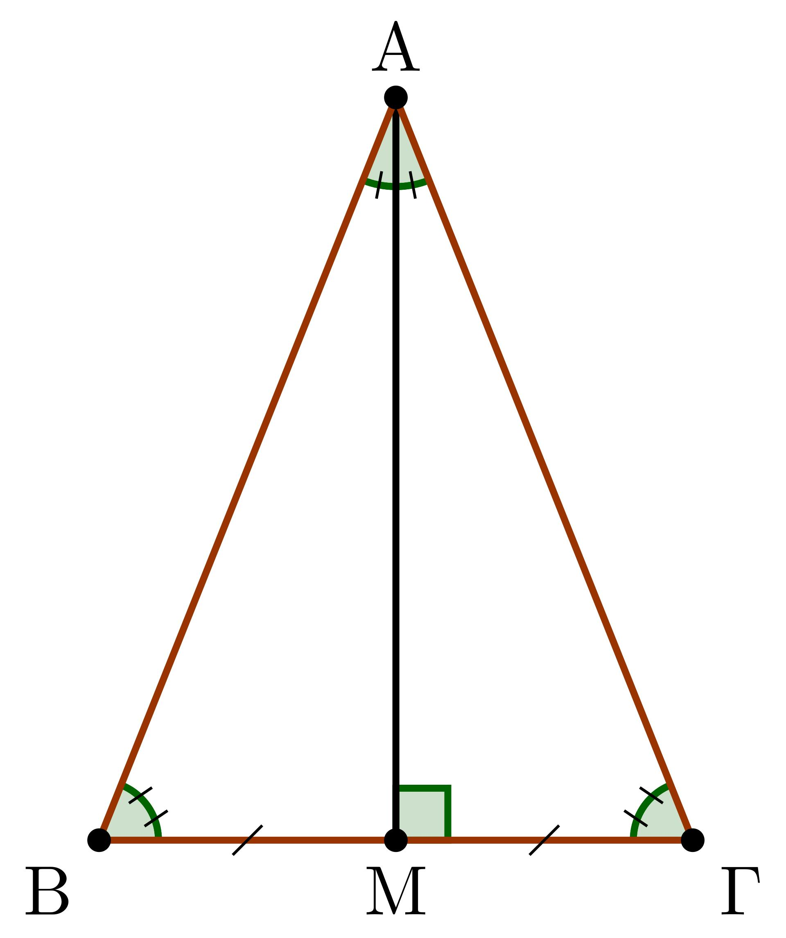
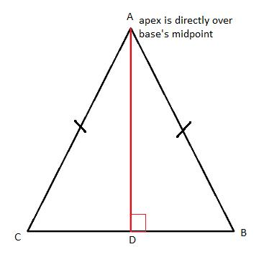
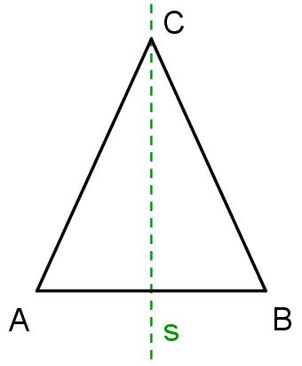
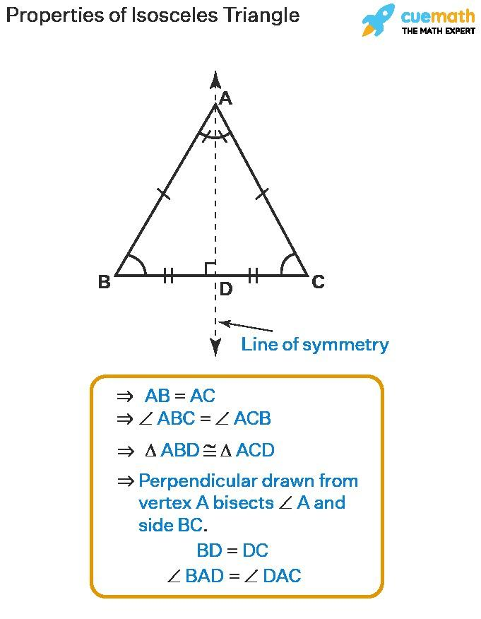
If $D$is the midpoint of $BC$, then $AD$is the symmetry axis.

Median, Altitude, and Angle Bisector
# Source: AI Source: Provided by: [Data Path: Persons Table -> ID Column: 1, Name_En Column: Motasem Essam] -> From: [ChatGPT] on [7/25/2026]
One of the most important properties of an isosceles triangle is that the segment from the vertex to the midpoint of the base has several roles.
If:
$$AB=AC$$
and $D$is the midpoint of $BC$, then $AD$is simultaneously:
- a median,
- an altitude,
- an angle bisector,
- a perpendicular bisector of the base.
Therefore:
$$\boxed{BD=DC} \\ \boxed{AD⊥BC}$$
and:
$$\boxed{∠BAD=∠DAC}$$
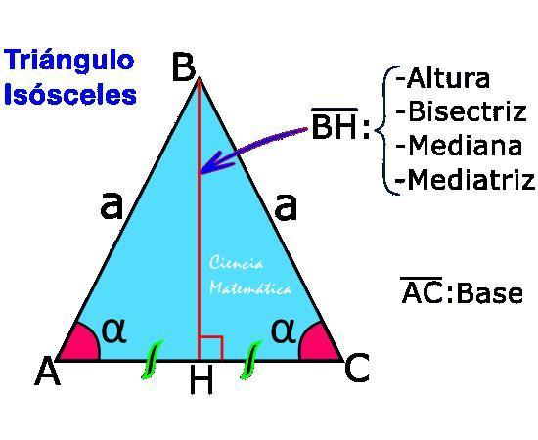
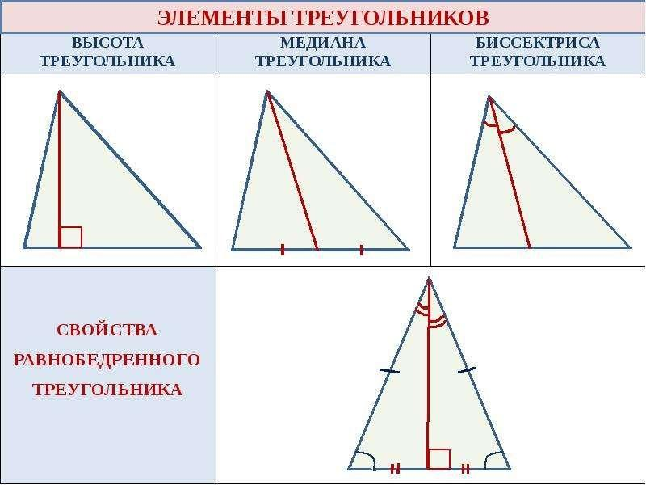
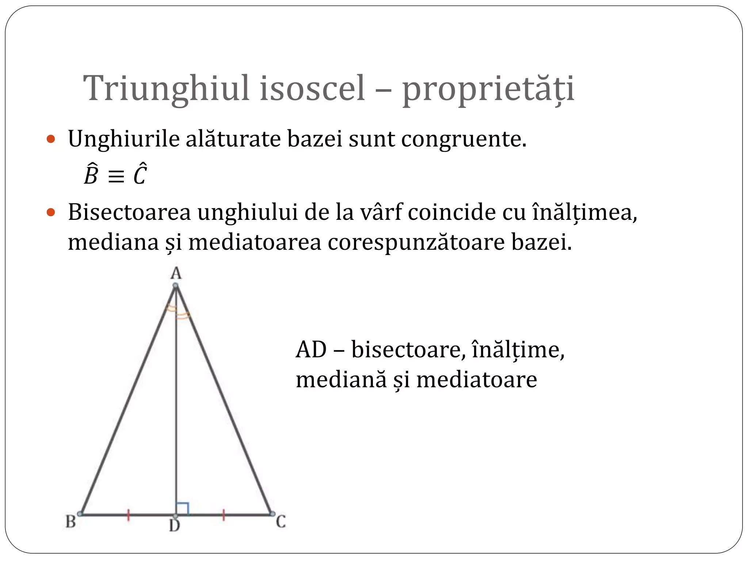
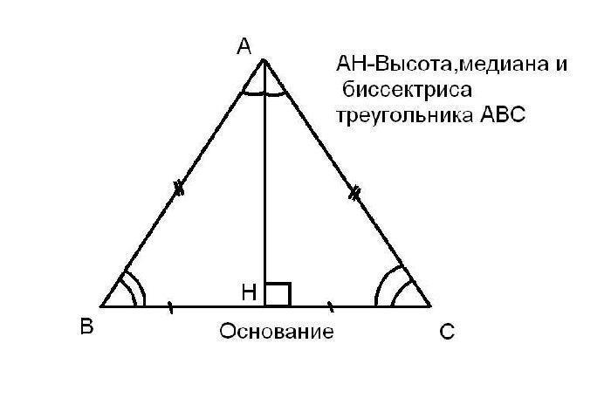

Area
# Source: AI Source: Provided by: [Data Path: Persons Table -> ID Column: 1, Name_En Column: Motasem Essam] -> From: [ChatGPT] on [7/25/2026]
The area of an isosceles triangle can be calculated using:
$$\boxed{A=\frac{1}{2}bh}$$
where:
- $b$= base,
- $h$= altitude to the base.
If the equal sides have length $a$and the base has length $b$, the altitude divides the base into two equal parts:
$$\frac{b}{2}$$
Using the Pythagorean theorem:
$$a^{2}=h^{2}+{\left(\frac{b}{2}\right)}^{2}$$
Therefore:
$$\boxed{h=\sqrt{a^{2}-\frac{b^{2}}{4}}}$$
and the area becomes:
$$\boxed{A=\frac{b}{2}\sqrt{a^{2}-\frac{b^{2}}{4}}}$$

Perimeter
# Source: AI Source: Provided by: [Data Path: Persons Table -> ID Column: 1, Name_En Column: Motasem Essam] -> From: [ChatGPT] on [7/25/2026]
If the equal sides have length $a$and the base has length $b$:
$$\boxed{P=2a+b}$$

Example — Area
# Source: AI Source: Provided by: [Data Path: Persons Table -> ID Column: 1, Name_En Column: Motasem Essam] -> From: [ChatGPT] on [7/25/2026]
Suppose an isosceles triangle has:
$$a=5\text{ cm}$$
for each equal side and:
$$b=6\text{ cm}$$
for the base.
The altitude is:
$$h=\sqrt{5^{2}-{\left(\frac{6}{2}\right)}^{2}} \\ h=\sqrt{25-9} \\ \boxed{h=4\text{ cm}}$$
Therefore:
$$A=\frac{1}{2}\left(6\right)\left(4\right) \\ \boxed{A=12{\text{ cm}}^{2}}$$

Relationship with Right Triangles
# Source: AI Source: Provided by: [Data Path: Persons Table -> ID Column: 1, Name_En Column: Motasem Essam] -> From: [ChatGPT] on [7/25/2026]
When the altitude is drawn from the vertex to the base, it divides an isosceles triangle into two congruent right triangles.
For the example above:
$$5-4-3$$
right triangles are formed.
Thus, isosceles triangles are frequently useful in problems involving:
- the Pythagorean theorem,
- right triangles,
- trigonometry,
- symmetry.

Classification by Angles
# Source: AI Source: Provided by: [Data Path: Persons Table -> ID Column: 1, Name_En Column: Motasem Essam] -> From: [ChatGPT] on [7/25/2026]
An isosceles triangle can also be classified according to its angles.
Acute Isosceles Triangle
All three angles are less than ${90}^{∘}$.
Right Isosceles Triangle
One angle is ${90}^{∘}$, and the other two are:
$$\boxed{{45}^{∘}}$$
Thus:
$$\boxed{{45}^{∘}-{45}^{∘}-{90}^{∘}}$$
The equal sides are the two legs of the right triangle.
Obtuse Isosceles Triangle
One angle is greater than ${90}^{∘}$, while the two equal base angles are acute.
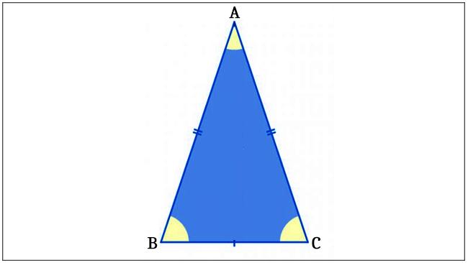
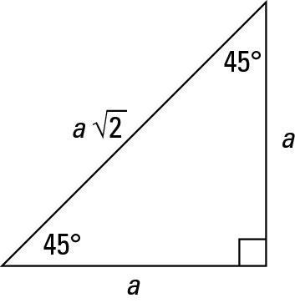
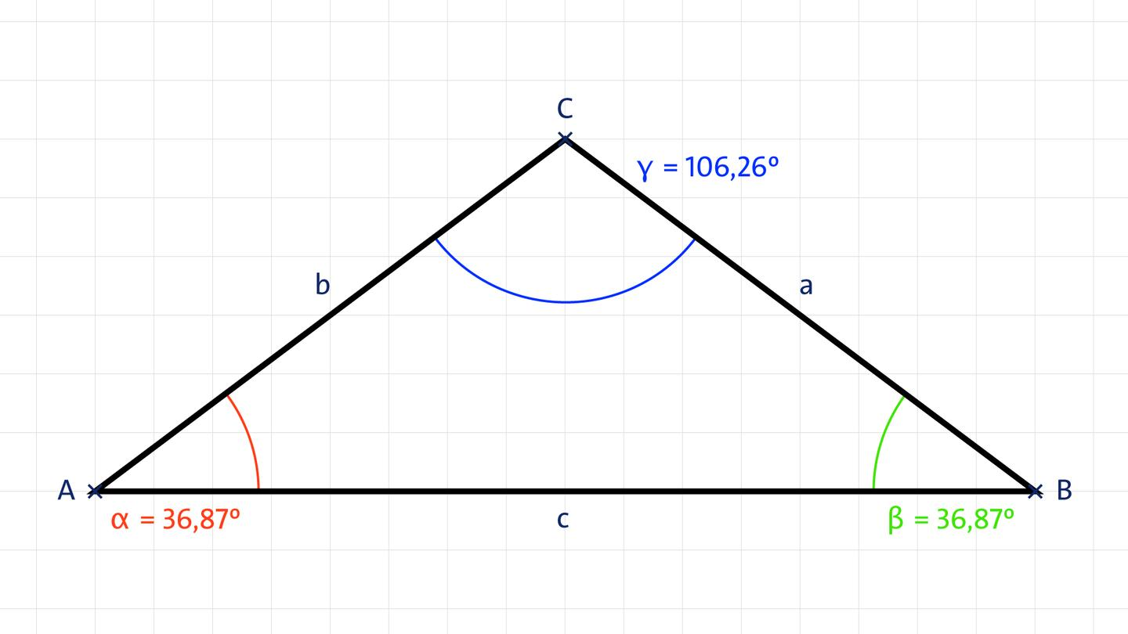
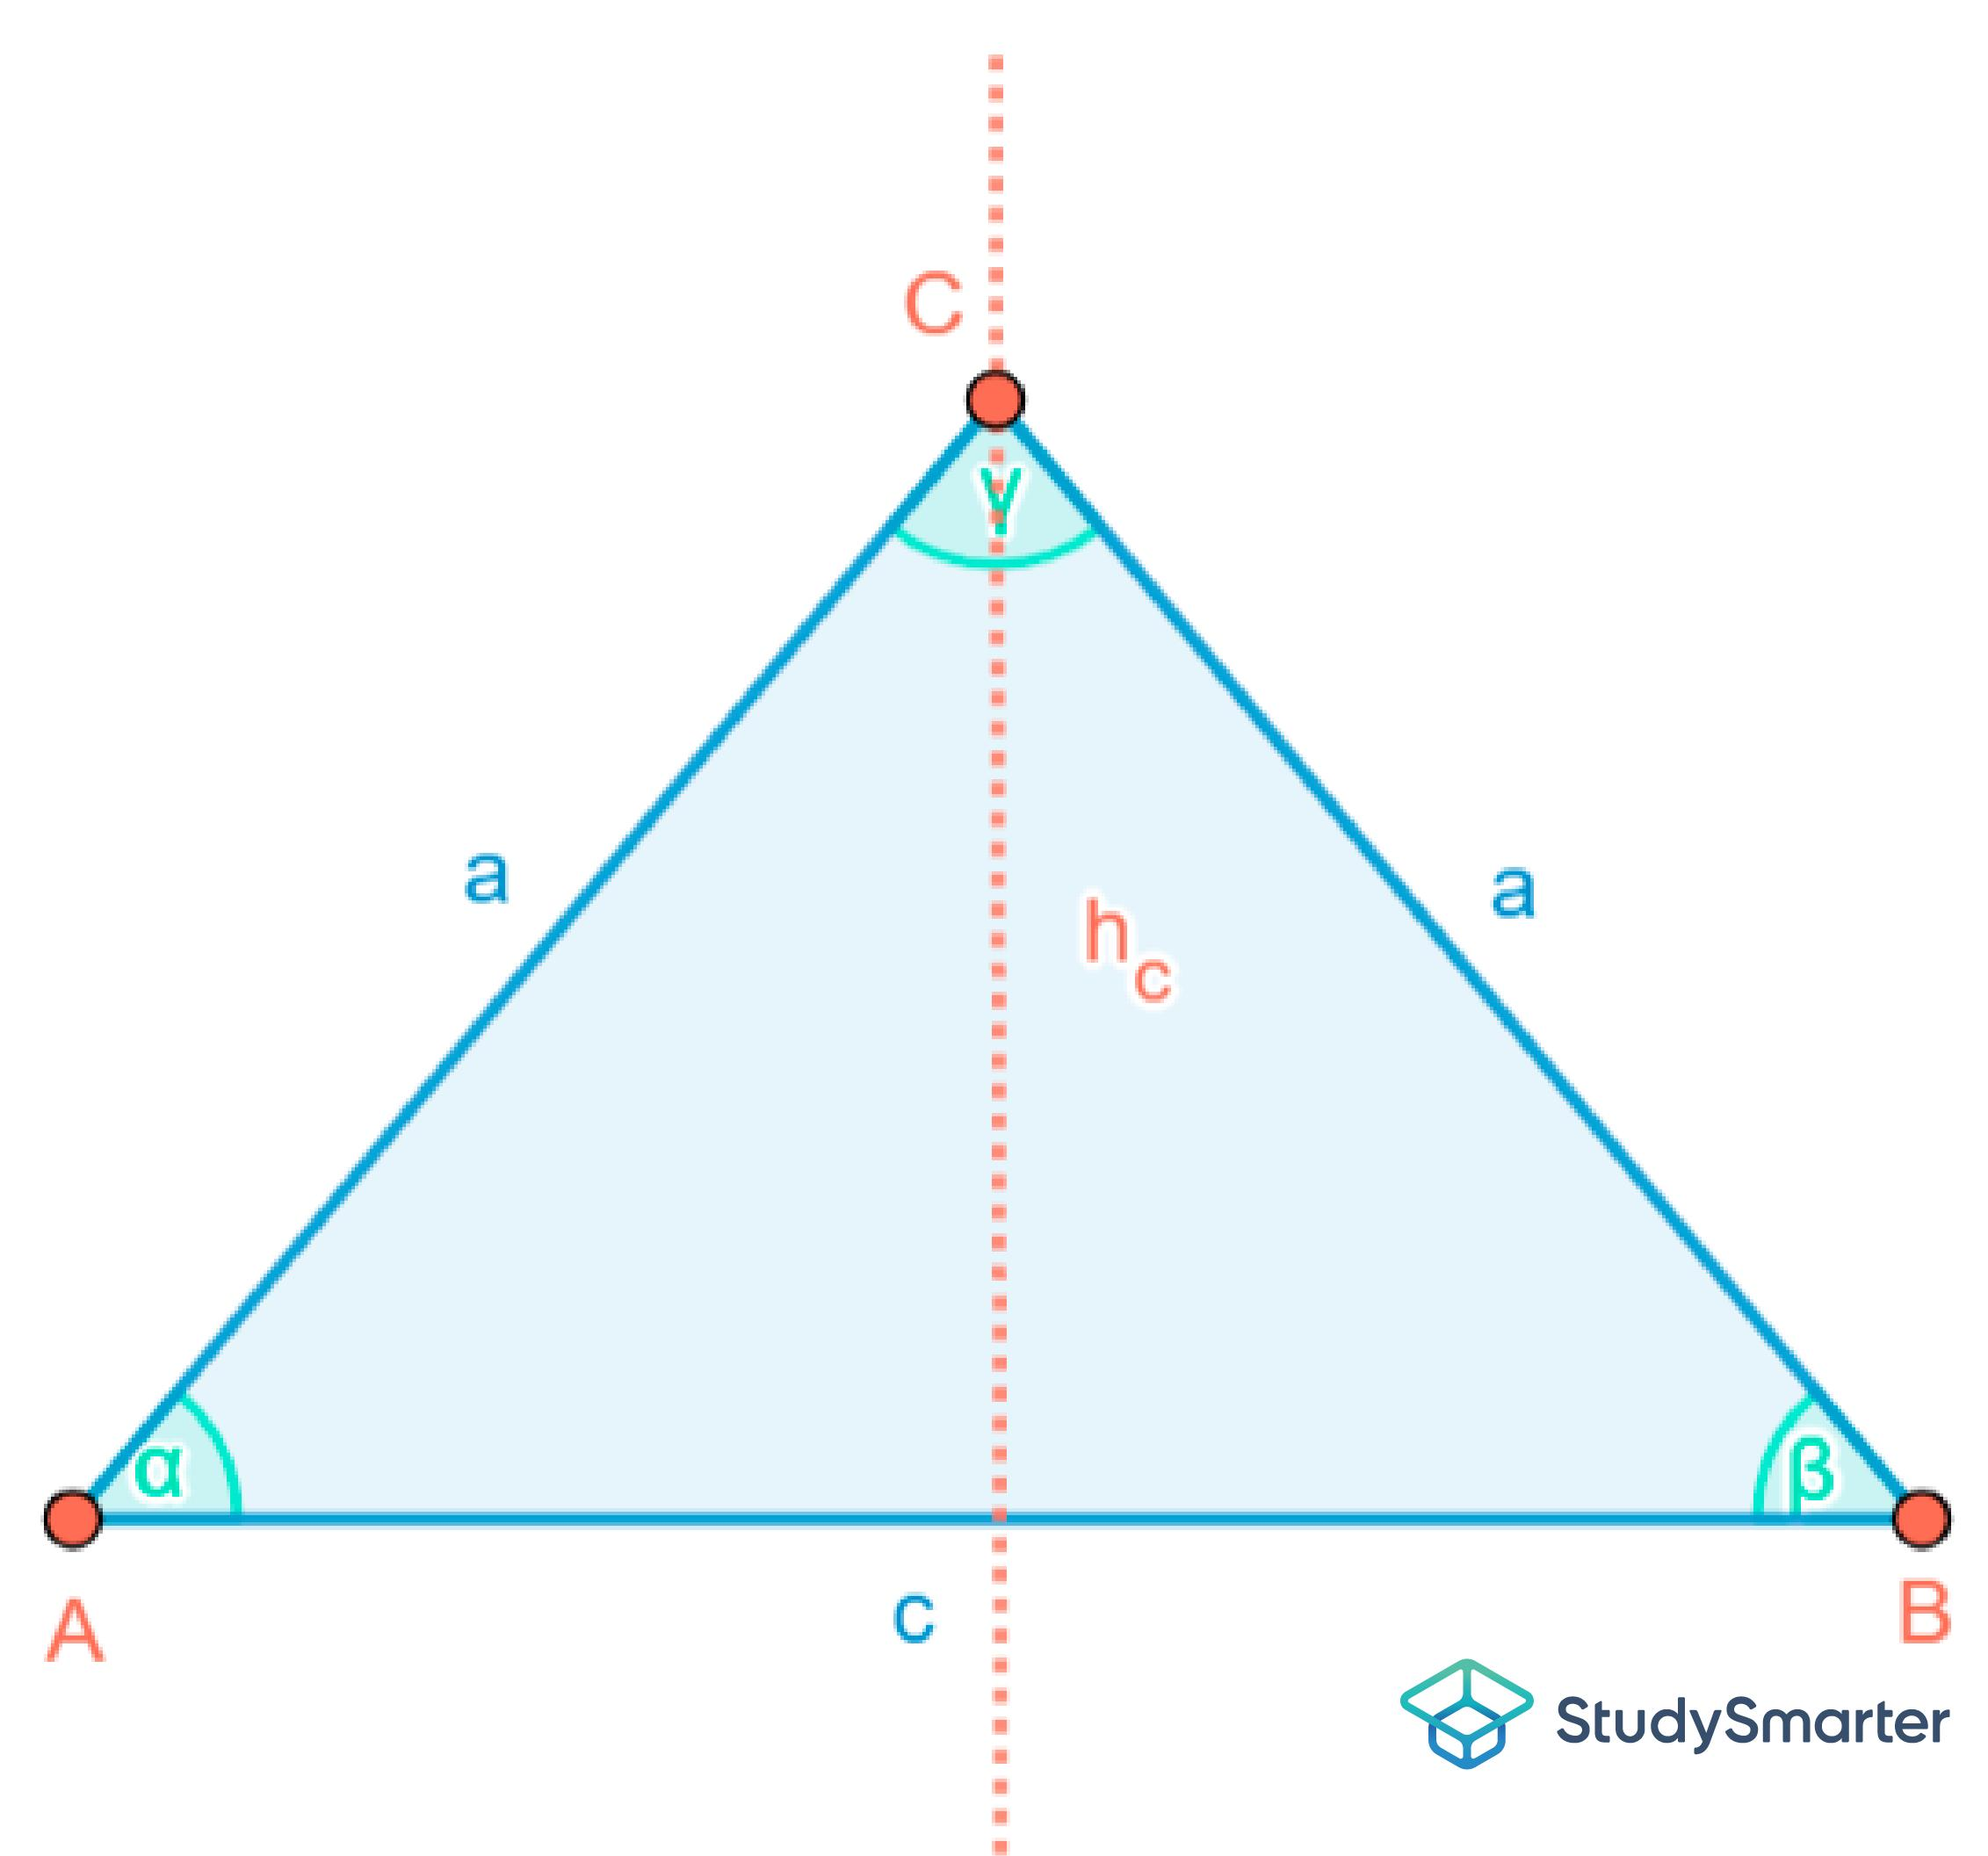
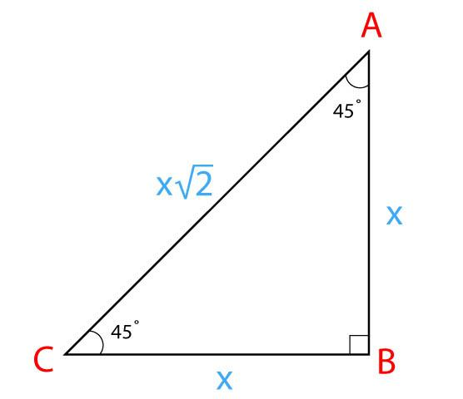
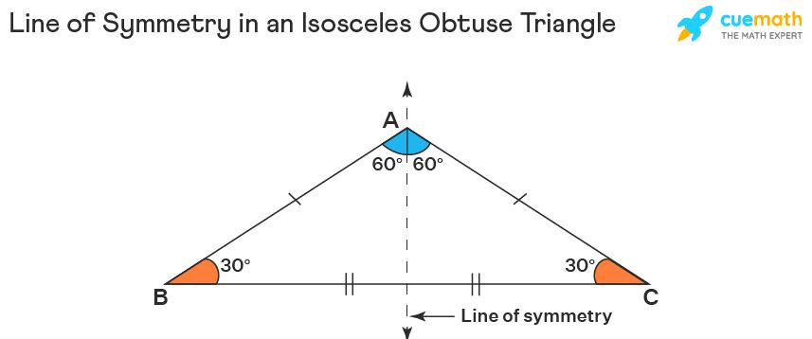

Triangle Centers
# Source: AI Source: Provided by: [Data Path: Persons Table -> ID Column: 1, Name_En Column: Motasem Essam] -> From: [ChatGPT] on [7/25/2026]
In an isosceles triangle, the symmetry axis contains several important triangle centers:
- Centroid $G$
- Incenter $I$
- Circumcenter $O$
- Orthocenter $H$
Therefore:
$$\boxed{G,I,O,H\text{ all lie on the symmetry axis}}$$
They do not generally coincide; they coincide only in the equilateral special case.
The symmetry axis is also the Euler line when the triangle is non-equilateral.

Relationship with Equilateral Triangles
# Source: AI Source: Provided by: [Data Path: Persons Table -> ID Column: 1, Name_En Column: Motasem Essam] -> From: [ChatGPT] on [7/25/2026]
An equilateral triangle is a special type of isosceles triangle under the broad definition:
$$\boxed{\text{Equilateral}⊂\text{Isosceles}}$$
because an equilateral triangle has at least two equal sides.
However, if your classification system defines an isosceles triangle as having exactly two equal sides, then the two categories are treated as mutually exclusive.
For a clean knowledge-base classification, it is useful to state which convention you use.

Relationship with Scalene Triangles
# Source: AI Source: Provided by: [Data Path: Persons Table -> ID Column: 1, Name_En Column: Motasem Essam] -> From: [ChatGPT] on [7/25/2026]
A scalene triangle has no equal sides:
$$\boxed{a≠b, b≠c, c≠a}$$
An isosceles triangle has at least two equal sides:
$$\boxed{a=b \text{or} b=c \text{or} c=a}$$

Comparison with Other Triangle Types by Sides
# Source: AI Source: Provided by: [Data Path: Persons Table -> ID Column: 1, Name_En Column: Motasem Essam] -> From: [ChatGPT] on [7/25/2026]
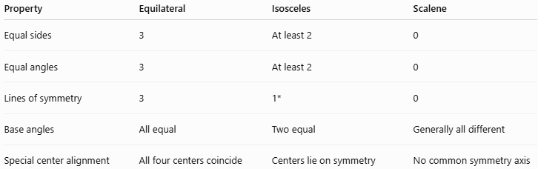
Property | Equilateral | Isosceles | Scalene
Equal sides | 3 | At least 2 | 0
Equal angles | 3 | At least 2 | 0
Lines of symmetry | 3 | 1* | 0
Base angles | All equal | Two equal | Generally all different
Special center alignment | All four centers coincide | Centers lie on symmetry axis | No common symmetry axis
(A non-equilateral isosceles triangle has exactly one line of symmetry.)

Real-World Applications
# Source: AI Source: Provided by: [Data Path: Persons Table -> ID Column: 1, Name_En Column: Motasem Essam] -> From: [ChatGPT] on [7/25/2026]
Isosceles triangles appear in:
- Roof structures.
- Bridges and trusses.
- Architectural designs.
- Supports and frames.
- Engineering structures.
- Decorative patterns.
- Surveying.
- Computer graphics.
- Symmetrical designs.
Their symmetry is particularly useful when equal loads, equal distances, or balanced geometric structures are required.

Important Theorems
# Source: AI Source: Provided by: [Data Path: Persons Table -> ID Column: 1, Name_En Column: Motasem Essam] -> From: [ChatGPT] on [7/25/2026]
Isosceles Triangle Theorem
If two sides of a triangle are equal, then the opposite angles are equal:
$$\boxed{AB=AC⇒∠B=∠C}$$
Converse
If two angles are equal, then the opposite sides are equal:
$$\boxed{∠B=∠C⇒AB=AC}$$
Symmetry Property
The median from the vertex to the base is also an altitude and angle bisector:
$$\boxed{\text{Median}=\text{Altitude}=\text{Angle Bisector}=\text{Perpendicular Bisector}}$$
for that vertex-to-base segment.

Key Formulas
# Source: AI Source: Provided by: [Data Path: Persons Table -> ID Column: 1, Name_En Column: Motasem Essam] -> From: [ChatGPT] on [7/25/2026]
For equal sides $a$and base $b$:
Perimeter
$$\boxed{P=2a+b}$$
Altitude
$$\boxed{h=\sqrt{a^{2}-\frac{b^{2}}{4}}}$$
Area
$$\boxed{A=\frac{b}{2}\sqrt{a^{2}-\frac{b^{2}}{4}}}$$
Base Angles
If the vertex angle is $A$:
$$\boxed{∠B=∠C=\frac{{180}^{∘}-∠A}{2}}$$

Key Points
# Source: AI Source: Provided by: [Data Path: Persons Table -> ID Column: 1, Name_En Column: Motasem Essam] -> From: [ChatGPT] on [7/25/2026]
- An isosceles triangle has at least two equal sides.
- The angles opposite the equal sides are equal.
- It has a line of symmetry in the non-equilateral case.
- The vertex-to-base median is also an altitude and angle bisector.
- The same segment is also the perpendicular bisector of the base.
- An isosceles triangle can be acute, right, or obtuse.
- A right isosceles triangle has angles:
$$\boxed{{45}^{∘},{45}^{∘},{90}^{∘}}$$
- Under the broad definition, an equilateral triangle is a special case of an isosceles triangle.

Conclusion
# Source: AI Source: Provided by: [Data Path: Persons Table -> ID Column: 1, Name_En Column: Motasem Essam] -> From: [ChatGPT] on [7/25/2026]
An isosceles triangle is characterized by equality of at least two sides and the corresponding equality of their opposite angles. Its symmetry produces a particularly important geometric relationship: the segment from the unequal vertex to the base simultaneously acts as a median, altitude, angle bisector, and perpendicular bisector. This makes isosceles triangles especially important in triangle theorems, symmetry, coordinate geometry, and trigonometry.

